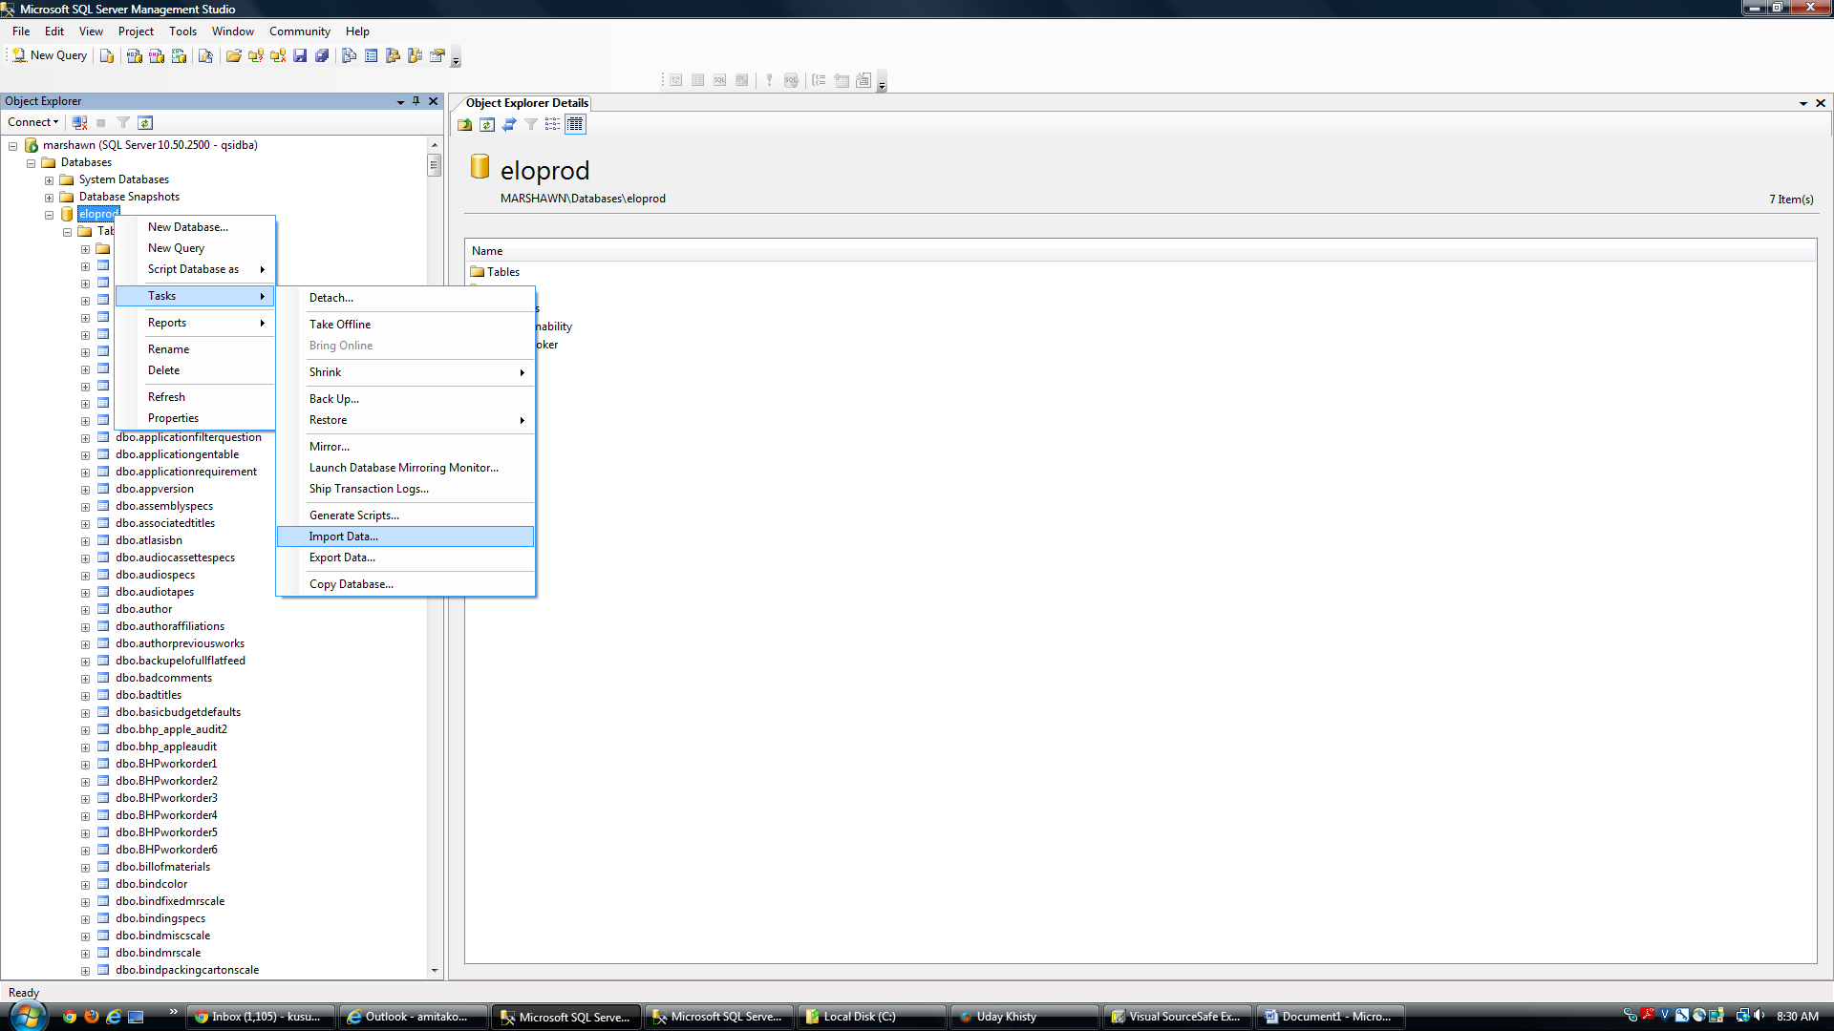

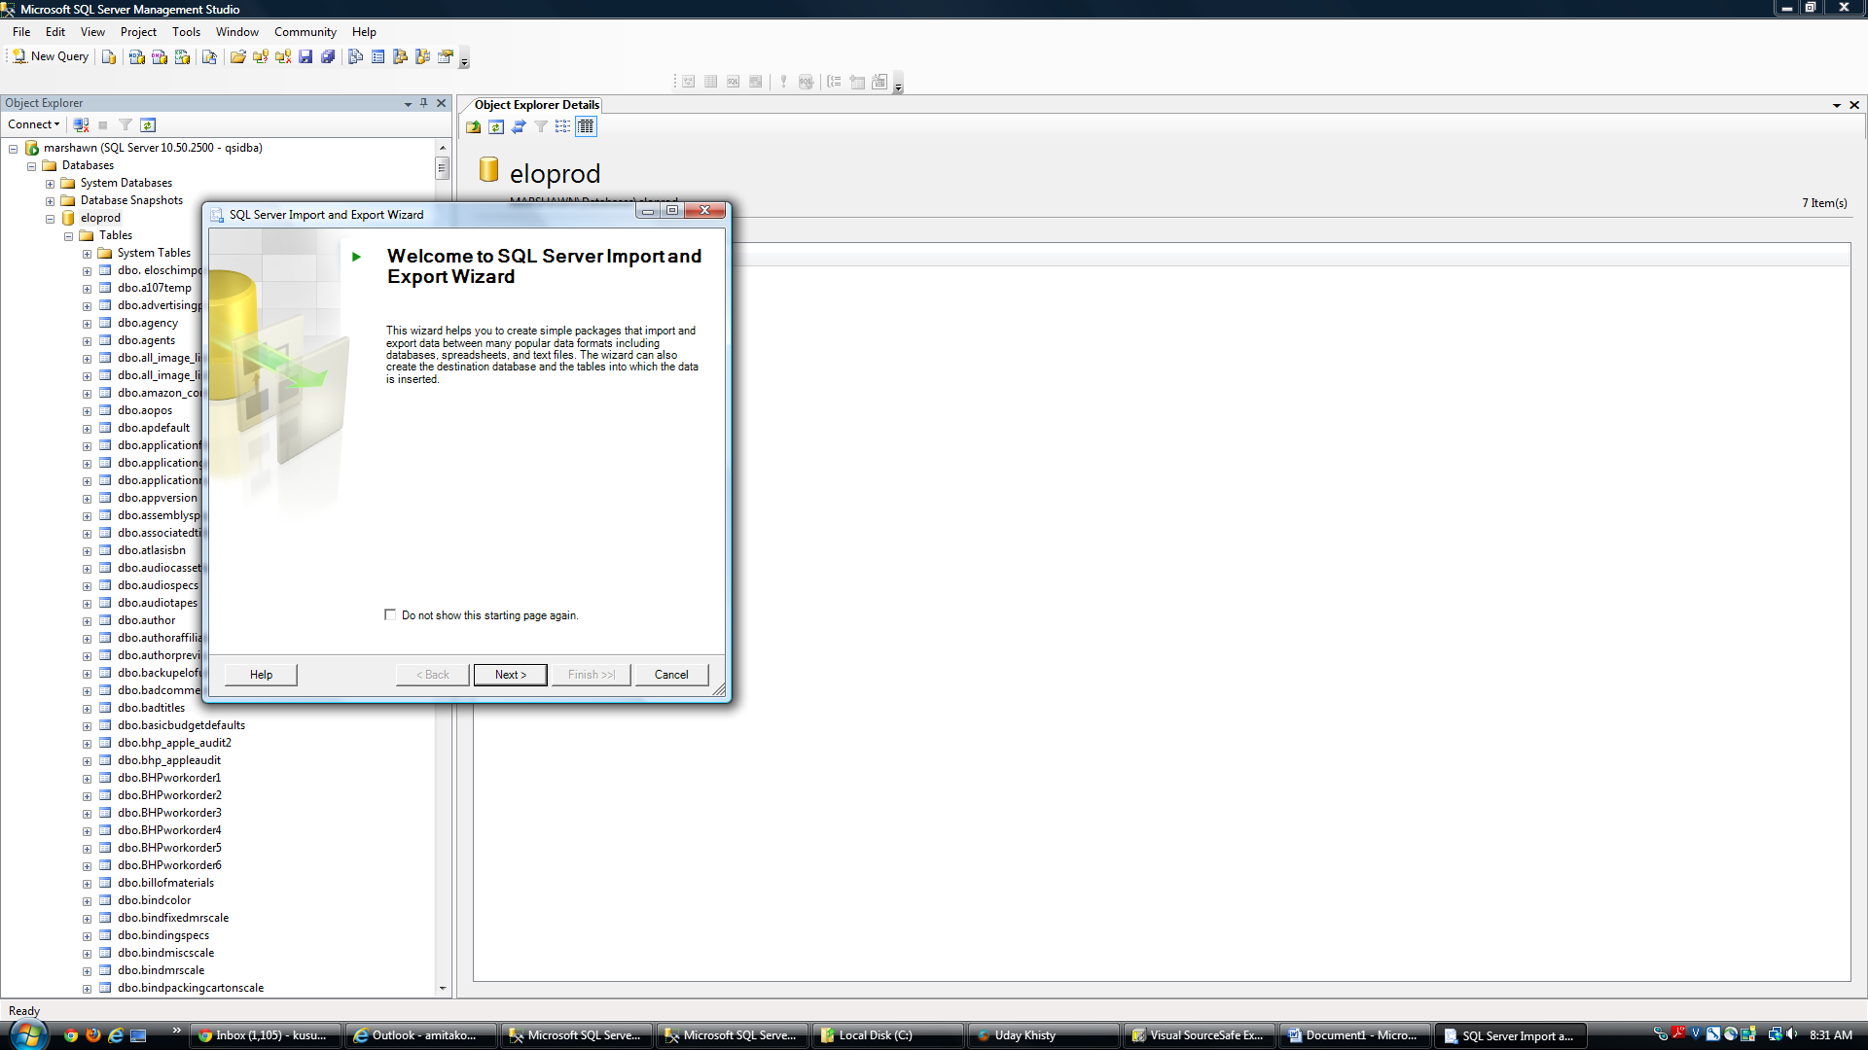

Click ‘Next’

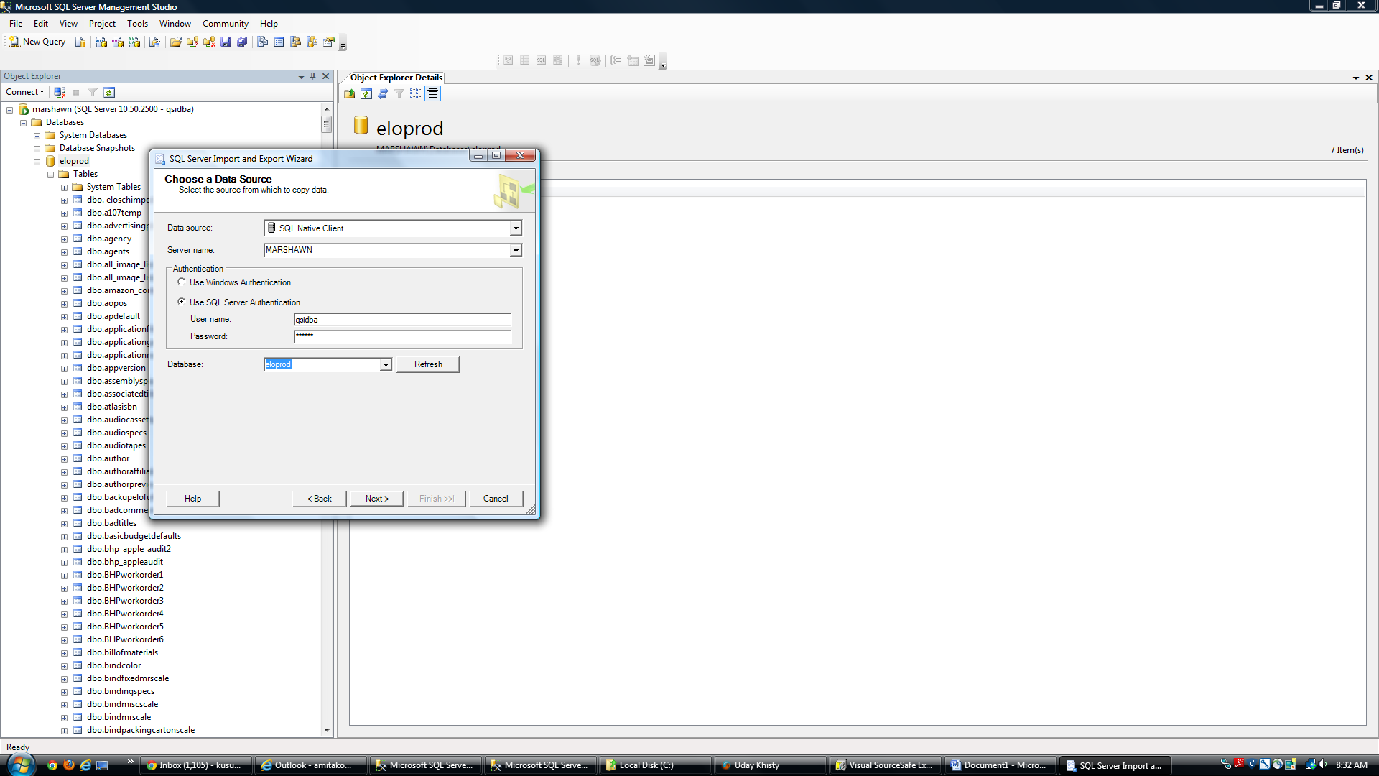

Fill in fields as above – click ‘Next’

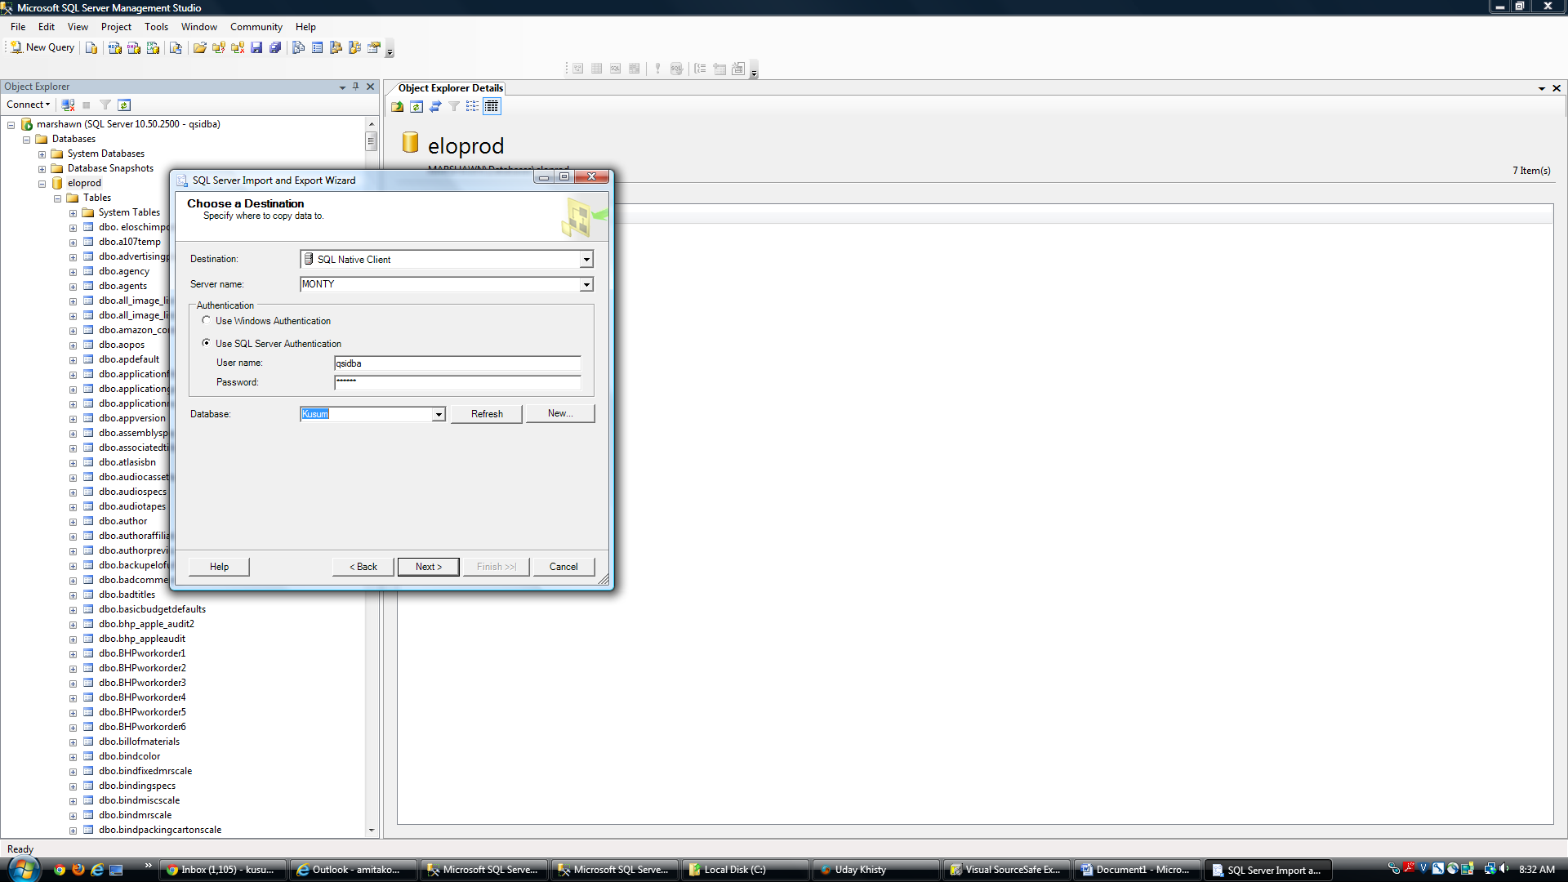

Fill in fields as above – click ‘Next’

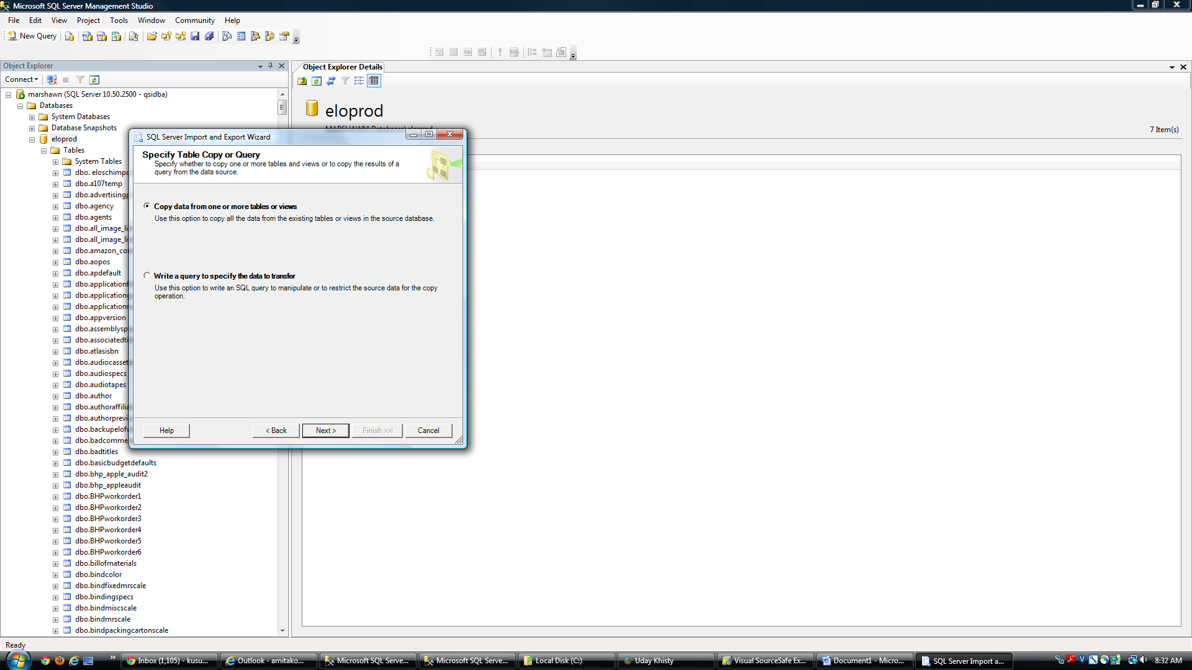

Click ‘Next’

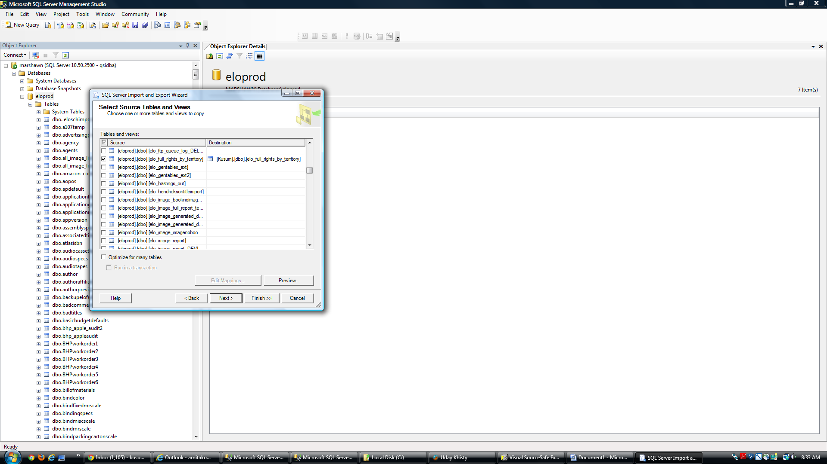

Scroll down in list of source tables to select the eloprod.dbo.elo_full_rights_by_territory as well as the correct destination table –click ‘Next’

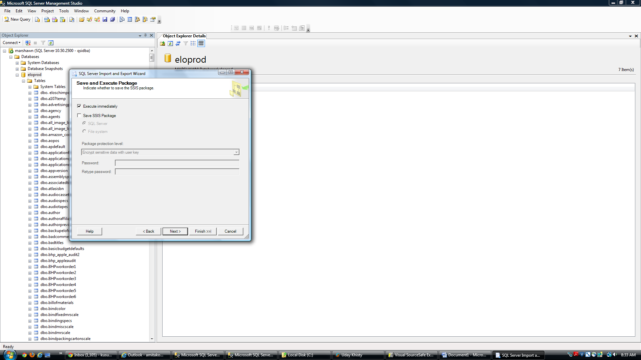

Click ‘Next’

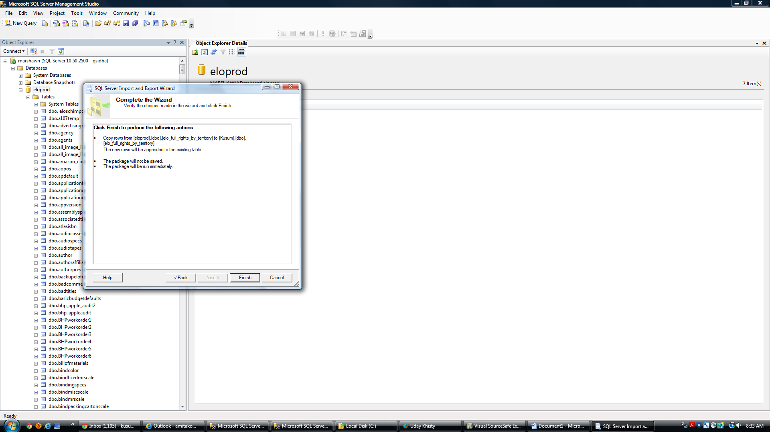

Click ‘Finish’

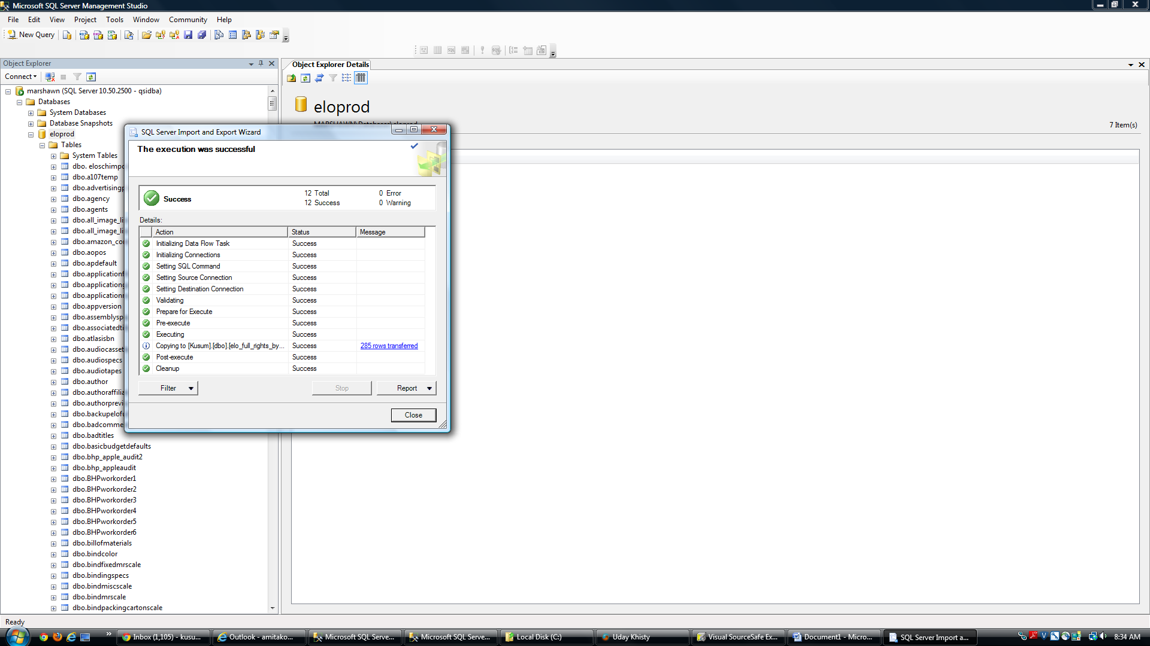

Click ‘Close’

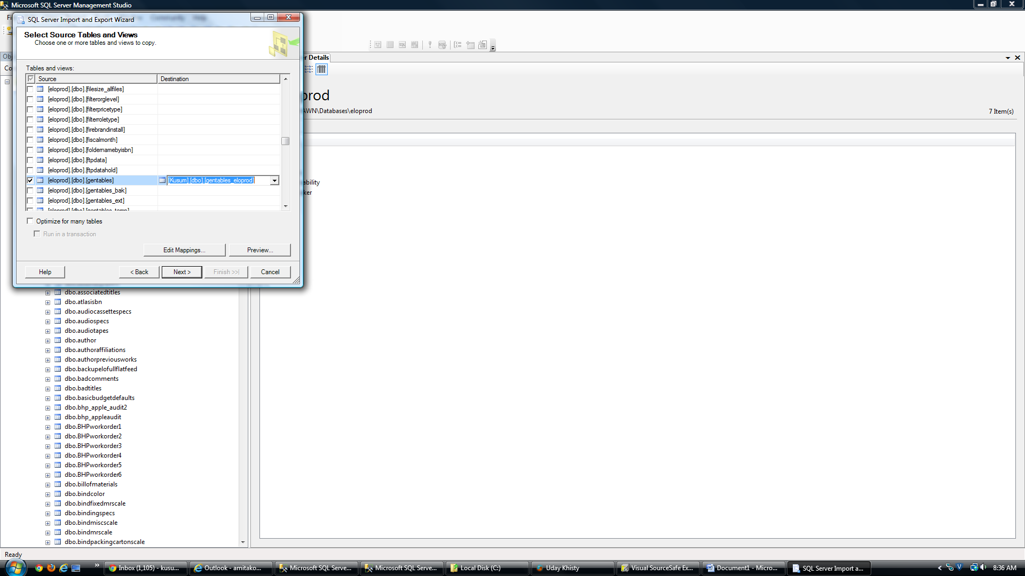

IMPORTANT:

When importing the gentables from marshawn make sure the destination table selected is:

Databasename.dbo.**gentables_eloprod**